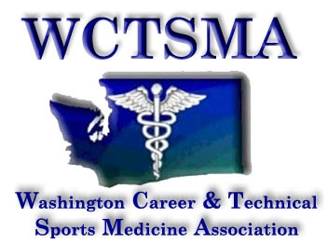

September 8, 2015 (Tuesday, 6 am)
BOD Conference Call Agenda
Phone number: (888) 617-3400 pw 397051#

Members Present: Angela Bushmaker, Larry Howe, Gary Clinton, Erika Ebe, JC Lutchkoff, Marianna Goheen, Tom Dimmel

Members Absent: Robin Backstrom

Meeting of the whole: Motion: Gary Clinton, 2nd Larry Howe

Agenda:
- Tri-Cities contracts: working on 18
- Funding update: Gary - waiting on funding; will work on it with tristan
- Mailing: students (Erika & JC) will get it out this week
- Webmaster contract: send to Gary
- Leadership Group Helper: Chris will contact
- Children’s Update: sent to childrens and a follow up email to
Andrew Little last week
- DJO: new exhibitor sponsor
- WL Update: dec 2 @ Everett
- Civic Engagement Day 1/27/15: TBA
- Leadership Speakers-Fundraise by students for high end speakers:
Erin Jones? Conflict because she is running for OSPI
- HSCTE Update-Heather Brown our Liaison per WA-ACTE meeting:

Action Items:
- Larry send out bi-weekly report
- $10 / alumni; $40 / professional
- Larry corporate form for membership
- Erika & JC intro letter
- Chris contact helpers
- Larry contact Tim about Erin Jones conflict
- Larry membership out of state & student issues
- Marianna/Angela bylaws

