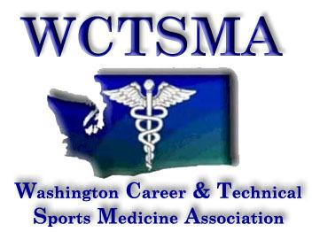

April 21st, 2018 (Saturday, 8:15AM)
Three Rivers Convention Center

Members Present: Larry Howe, Tom Diimmel, Gary Clinton, Heather Sevier, Bud Bannon, Chris Hiatt, WCTSMA Membership

8:20AM: Meeting begins
8:30AM: Motioned/seconded/approved to approve treasurer’s report

Agenda:
- By-law changes
- Treasury
  - $6000 grant to savings
  - Potential future issues with Perkins- planning ahead
  - Planned audit upcoming for Perkins/OSPI (from Mariana)
- Next year- Tacoma
  - April 18-20
  - Spokane 2020
- SOD Report
  - 25 students applied for positions
  - 18 interviewed
- Student Officer Leadership Training
- NHSSM
- Vice President
  - Online
  - Plaques
- Voting Results
- Student Officer Director
  - Jake Howell wins
- VP- Voting
  - Julie Leslie wins
- Secretary
  - 900 students
  - 50 schools
  - Meeting minutes archive
- Fall Leadership
  - 9/29 or 10/6
- BOD Retreat
  - July 20th, 2018
- WSATA
  - July 21
- Civic Engagement Day
  - 1/31/19
- National Competition
- Coaches Association Payment
  - Benefits
  - Reminder to sign up on WSCA on website
Motioned/approved/seconded to move out of meeting of the whole
Meeting ended

Action Items:

